Module 4 – NIEM Model Content

**Slide 1 – Welcome Slide**

Welcome to Module 4: NIEM Model Content

**Slide 2 – Module Overview**

Module Overview

In this module we will discuss NIEM’s Model Content. The topics that we will cover are:

* Model Content Overview
* Application to NIEM Domains
* Model Management
* Content Management and
* Additional Resources

**Slide 3 – Model Content Overview**

Model Content Overview

NIEM consists of various elements. In this context, an “element” is any data component used within NIEM. Some elements are as simple as only having a term and definition associated with it. Others are more complex and may depend on other elements in terms of their association and meaning. Elements are to NIEM as words are to a dictionary.

NIEM has two general vocabularies:

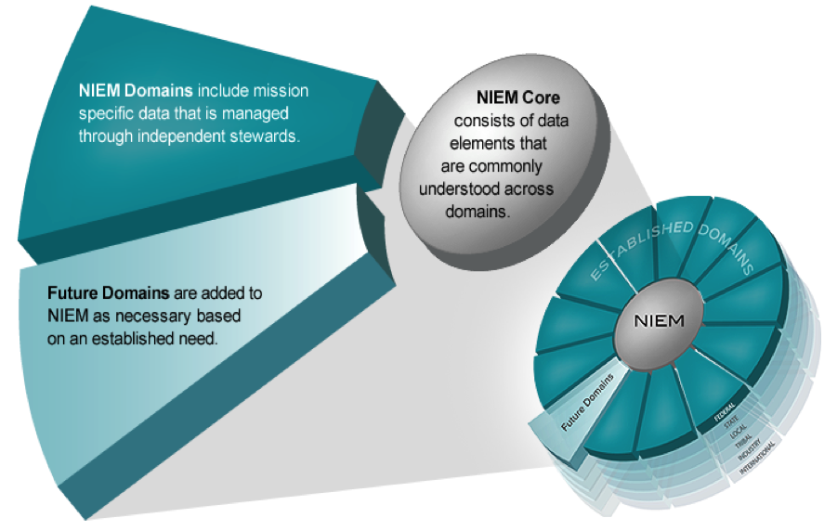

* NIEM Core: The NIEM core consists of data elements that are commonly understood and defined across domains; these elements are agreed upon by all of the communities who use NIEM. It is governed jointly by all NIEM domains.

NIEM is comprised of over 10,000 elements. Here are some examples of elements in NIEM Core and their sub-elements below it. Click on the elements and sub-elements to learn more.

Person

• PersonBirthDate

• PersonBloodType

• PersonSSNIdentification

Organization

• OrganizationLocation

• OrganizaitionStatus

• OrganizationTaxIdentification

* NIEM Domains: NIEM domains contain mission-specific data components that build upon NIEM core concepts to better align to a certain community supporting that mission. A NIEM domain represents both the governance and model content oriented around a community’s business needs.

**Slide 4 – Application of Model Content to NIEM Domains**

Application to NIEM Domains

NIEM domains are formally established communities with stewards to represent the stakeholders, governance, and data model content oriented around their respective business needs.

NIEM provides common, agreed-upon terms, definitions, formats, and relationships independent of how information is stored in individual systems.

NIEM has model content for each of its domains and provides a platform to enable them to share and leverage content from other domains. In addition, NIEM also supports the creation of new model content—several emerging communities are actively working toward developing new content for NIEM, which may lead to the establishment of new domains.

**Slide 5 – How NIEM Content is Managed**

How NIEM Content is Managed

* Individual domains govern their own portion of the NIEM model and work with other NIEM domains to collaboratively identify areas of overlapping interest using established NIEM processes.
* As domain stakeholders develop and implement NIEM-based exchanges they provide new or updated information exchange requirements to the domain steward.
* Content updates can happen at any time, and are then incorporated into the next NIEM release for reconciliation and official publication.
* For each new release, the NIEM Business Architecture Committee (NBAC), NIEM Technical Architecture Committee (NTAC), and NIEM community work together to update the model.
* NIEM was designed to accommodate updates on a regular basis in order to evolve with user needs.
* To incorporate change on a predictable, structured, and sustainable manner, NIEM designed both a release cycle and core supplements to update the model.

Release Cycles

* NIEM’s Release Cycle is broken into Major and Minor Releases.
  + A Major Release can be expected every three years, with a minor release potentially occurring every 12 months.
    - Major Releases occur when the NIEM core and domains are updated and then synchronized.
    - Minor Releases occur to incorporate and synchronize changes to domain content, and may contain core supplements. Minor Releases are given version IDs such as 2.1, 2.2, 3.1, or 3.2.
  + A Major and Minor Release will not occur in the same calendar year. This process ensures that NIEM addresses community business requirements.

Core Supplements

* Core supplements are a special type of NIEM release that allows the program the flexibility to apply strictly additive changes to a previously published NIEM core.
  + A Core Supplement (CS) can be issued when the NBAC determines it is necessary to add content to a published NIEM core.
  + A CS does not have to be issued within a Major or Minor release cycle, although it can be.
  + The purpose for issuing a CS may include:
    - Updating a code list with new values added by an authoritative source
    - Correcting a significant flaw in a component, to add a new element to a substitution group
    - Applying other adjustments by adding content

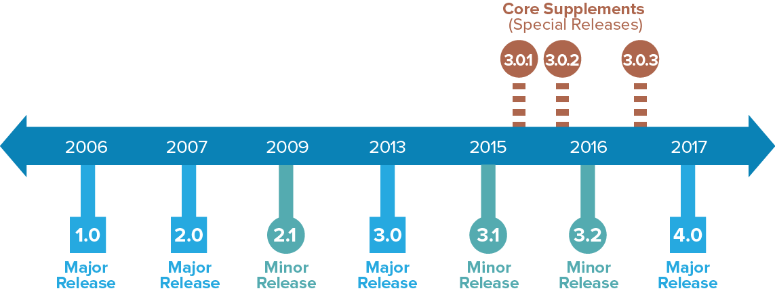

**Slide 6 – Harmonization**

Harmonization

* Harmonization is an important activity that helps keep the model easy for developers and business leaders to navigate and use.
* Harmonization is an ongoing process to ensure there is no duplication in the model as updates are made while it evolves to accommodate new community business requirements. The harmonization process integrates these new requirements while eliminating redundancy in the model.
* There are two types of harmonization:
  + Between domains - Each domain has its own process for updating its data model, depending on the domain’s business needs and resources available.
  + Between NIEM core and domains - Every new business requirement that's identified follows a review process:
    - Issue is identified and an initial assessment is conducted by the NIEM lead developers or self-identified by the domain(s).
    - Issue is reviewed periodically by the NBAC and is assigned to a team consisting of NBAC members with knowledge, expertise, and/or vested interest in resolving the issue.
    - The NBAC team works to resolve the issue and provides a recommended solution.
    - The NBAC reviews the recommended solution and accepts, rejects, or defers it for more information, which the team then supports.
    - When the solution is accepted, NIEM lead developers will include it in the next Major or Minor Release.

**Slide 7 – Additional Resources**

For an overview of additional NIEM resources related to this module, please visit the following links:

* INSERT <https://www.niem.gov/about-niem> LINK
* INSERT <https://www.niem.gov/communities/niem-community> LINK
* INSERT <https://beta.movement.niem.gov/#/> LINK
* INSERT <https://tools.niem.gov/niemtools/ssgt/index.iepd> LINK